Power BI Hands-on Practice

Importing the Two E-Commerce Datasets
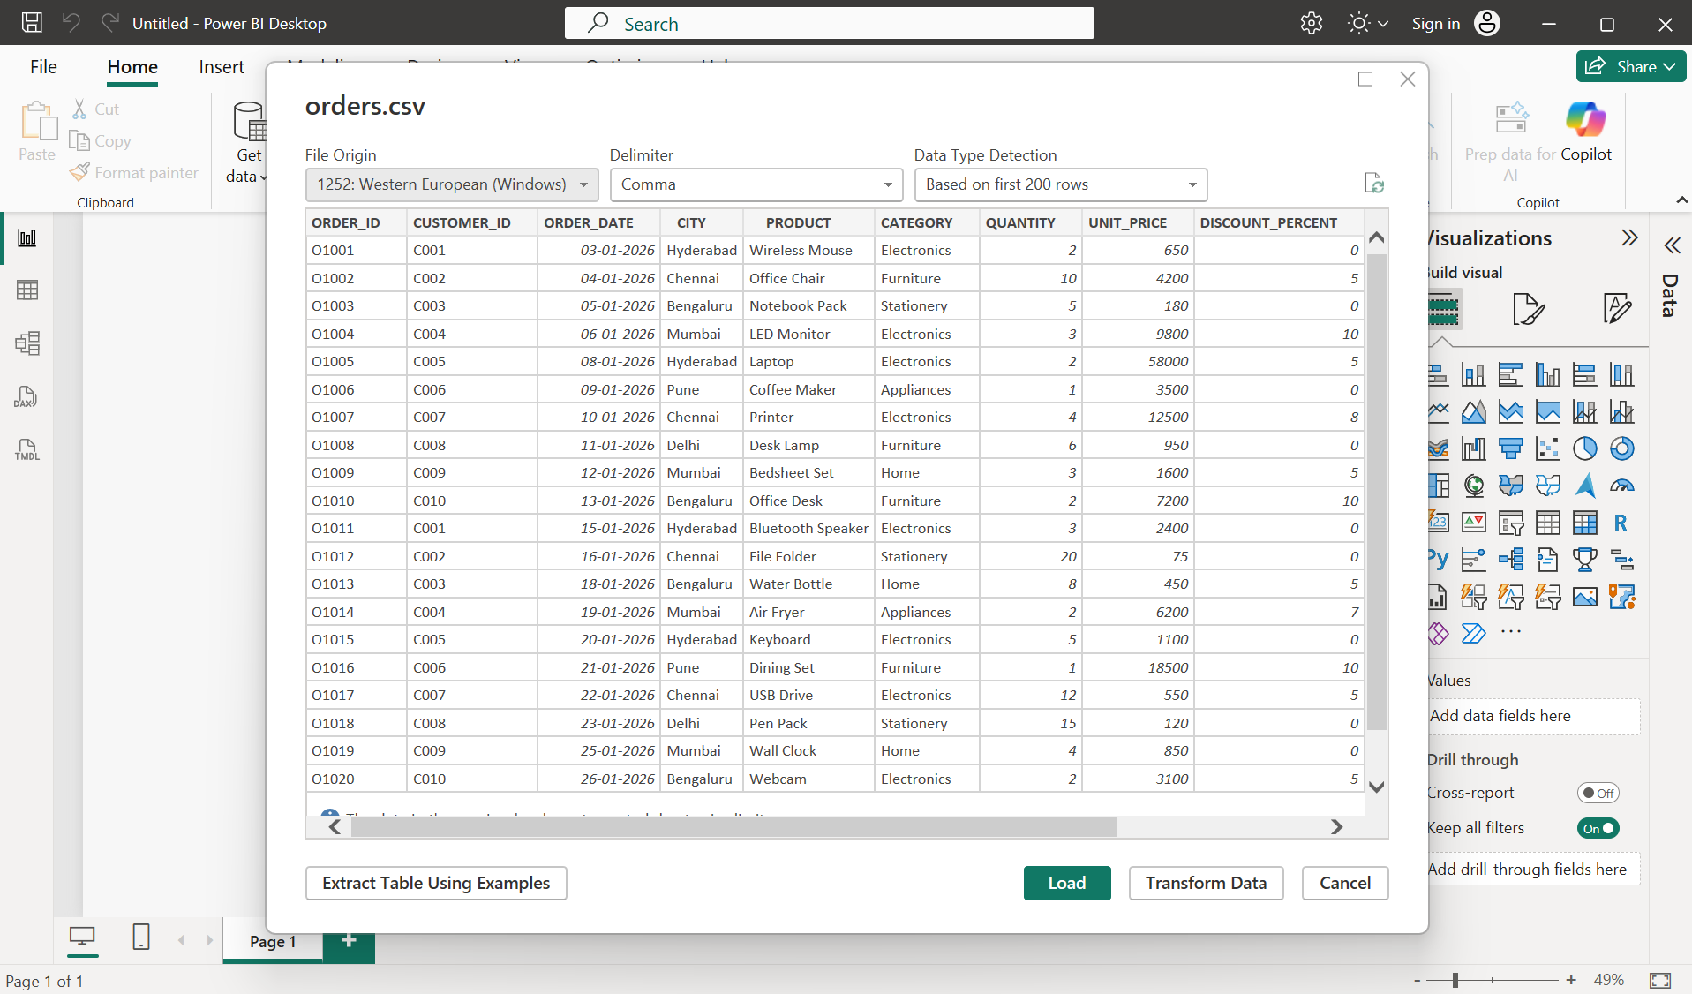
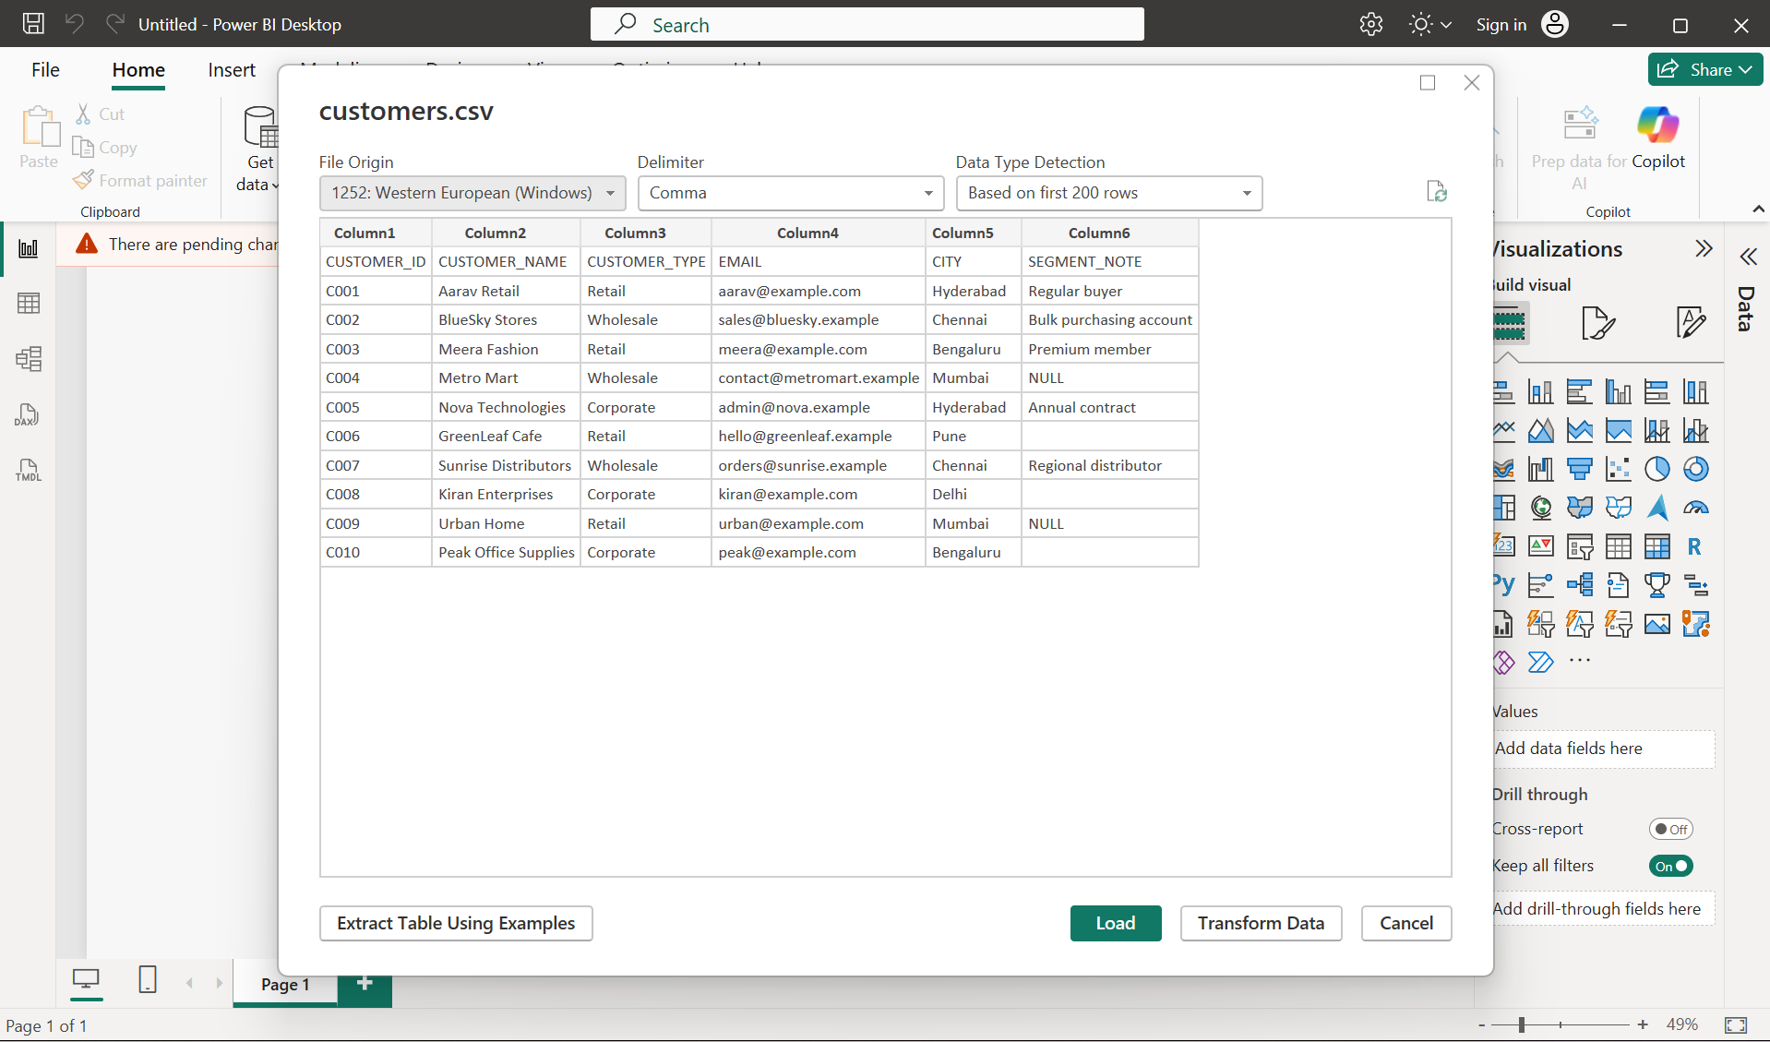

Exploring the Customers Table
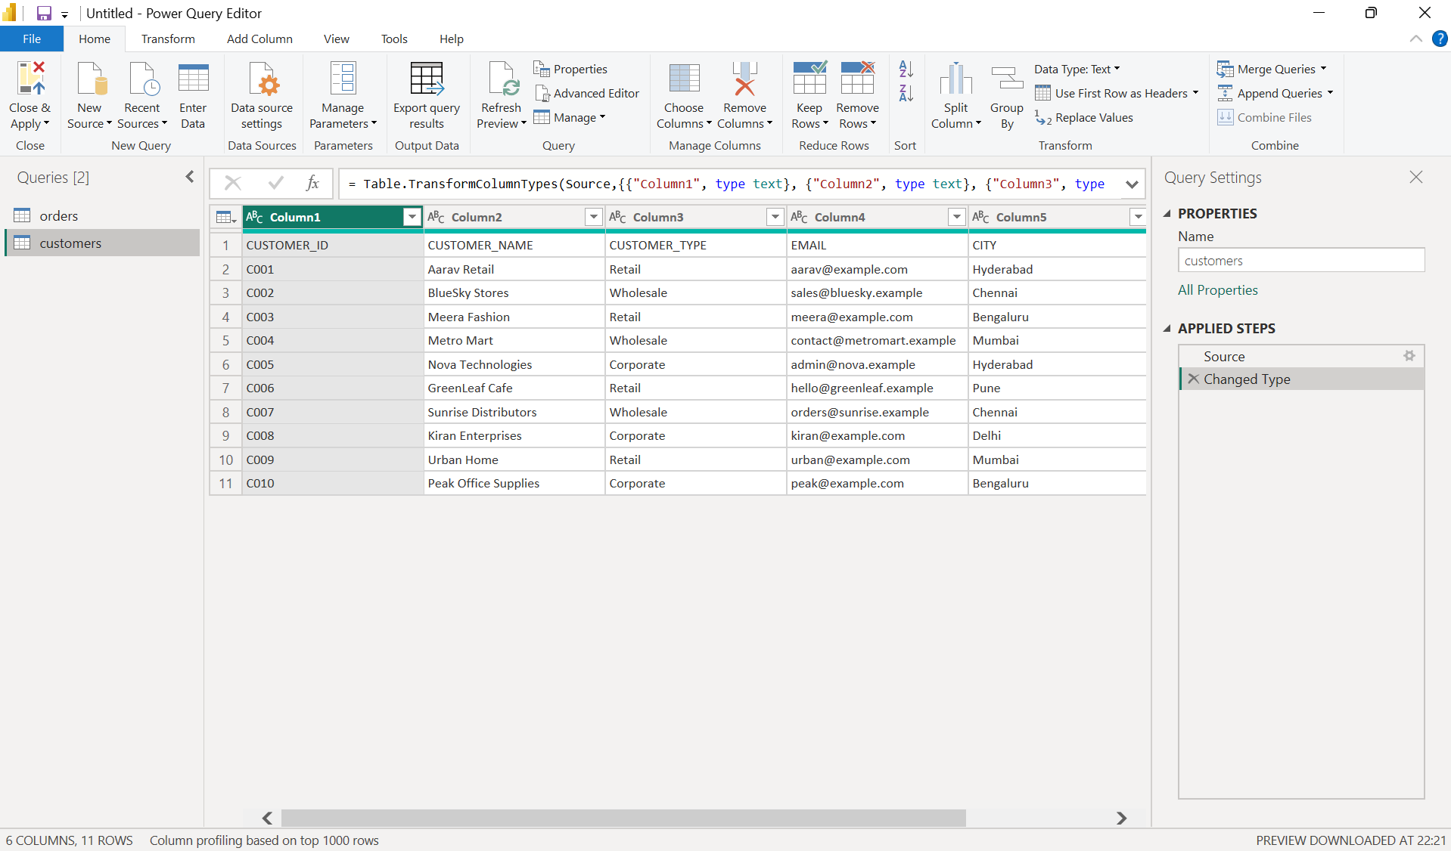

Exploring the Orders Table
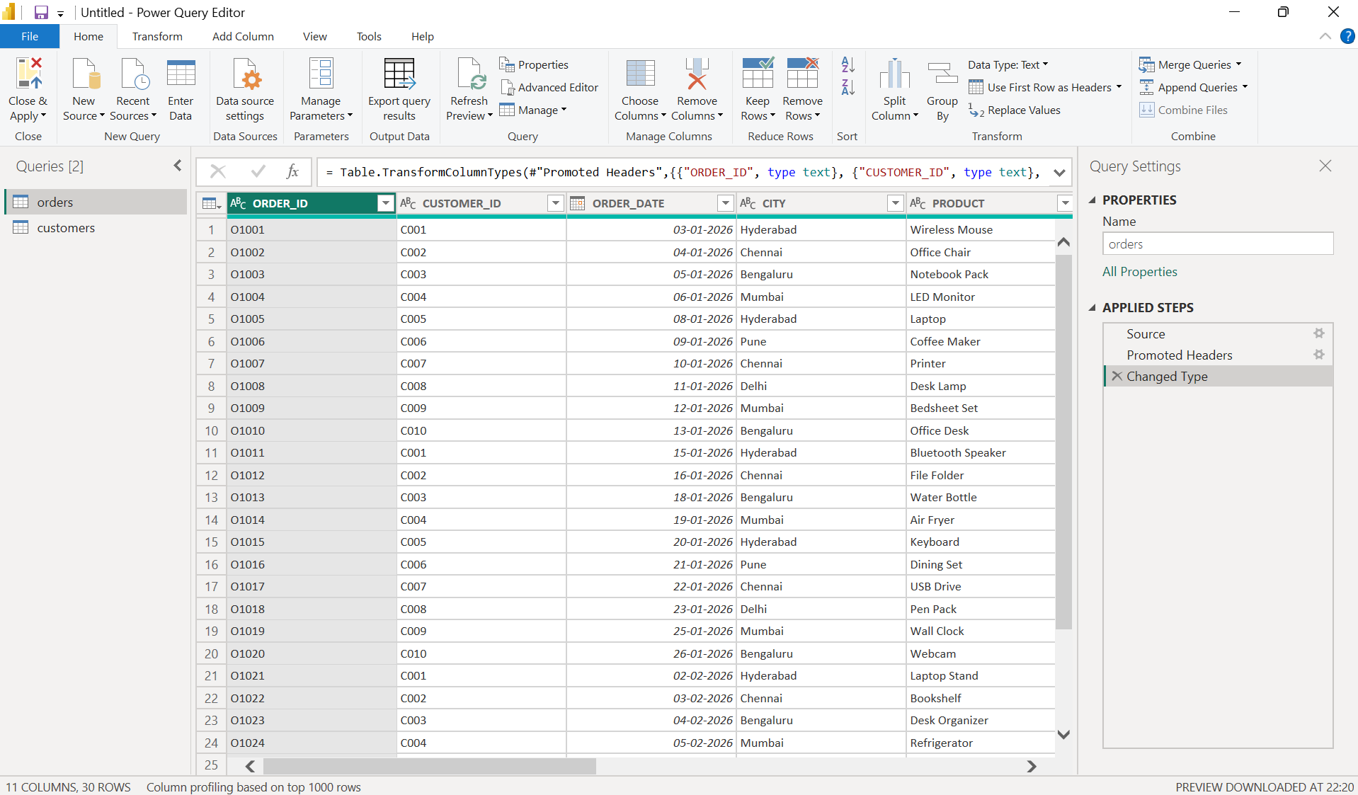

Cleaning Text Columns Using Trim and Clean
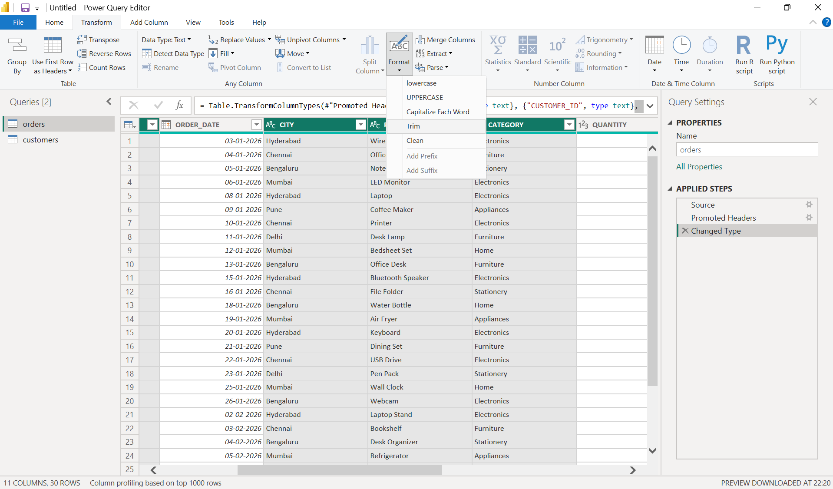
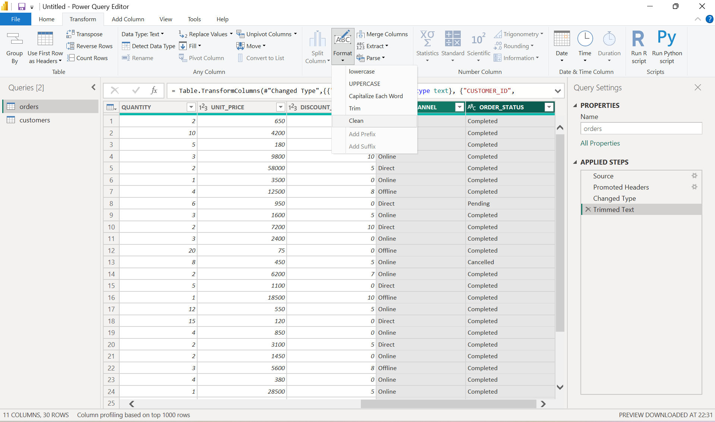
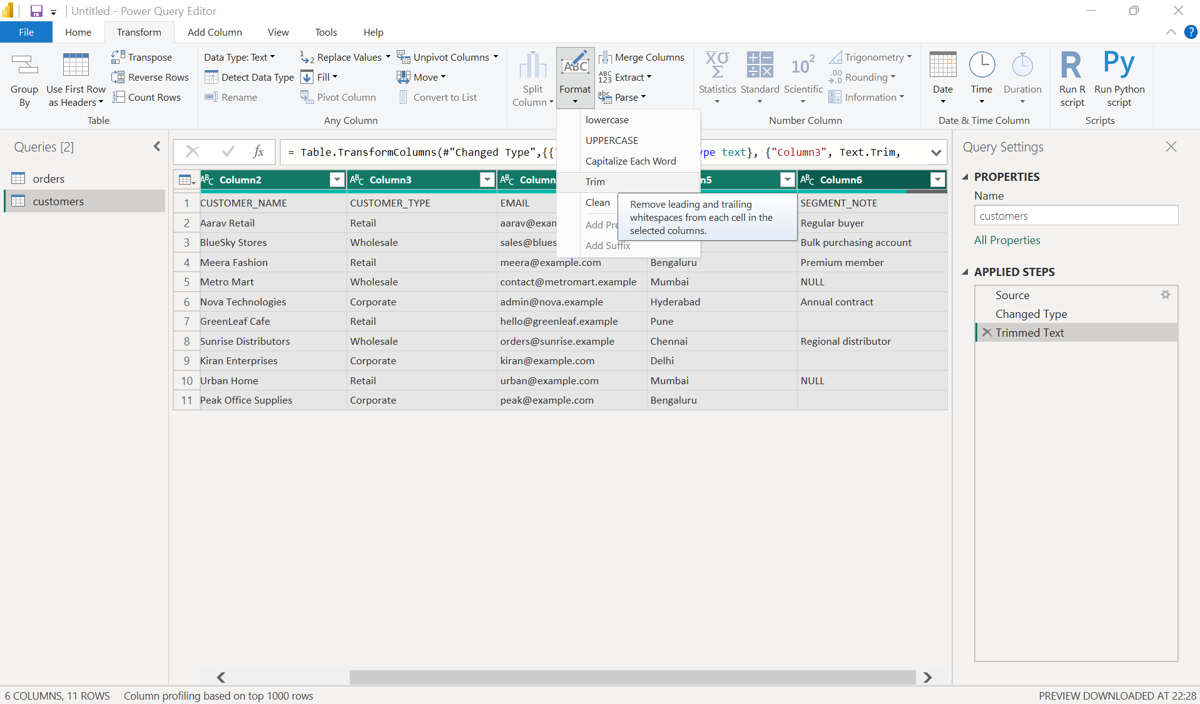
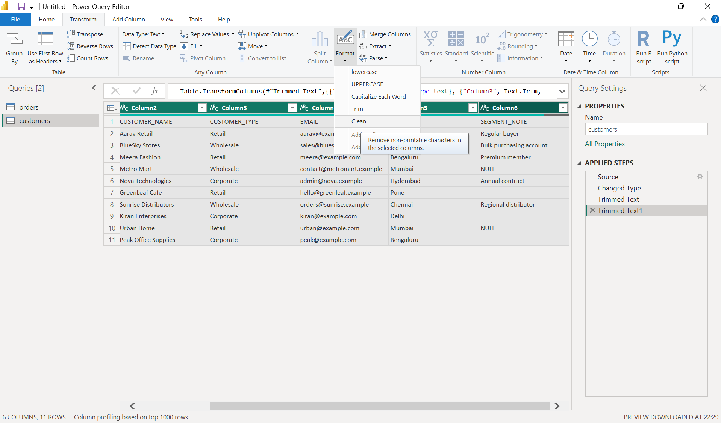

Standardizing Text Values
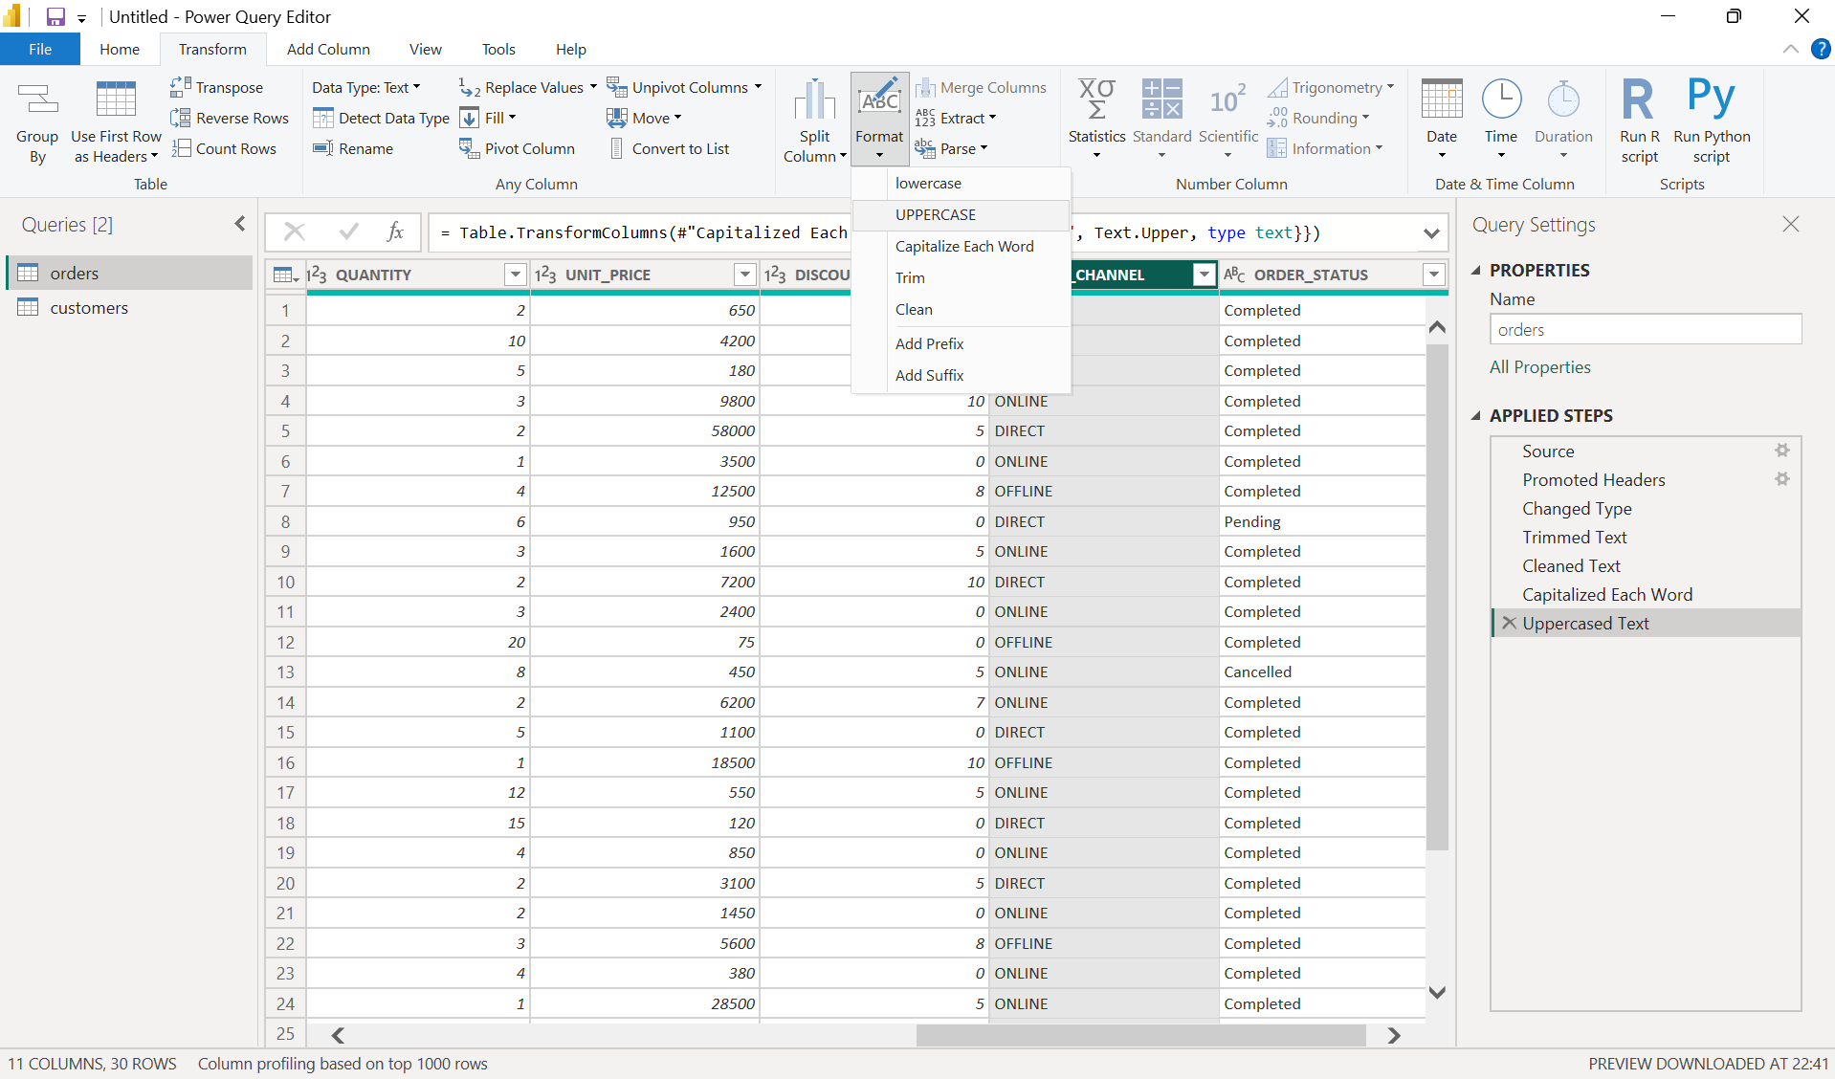

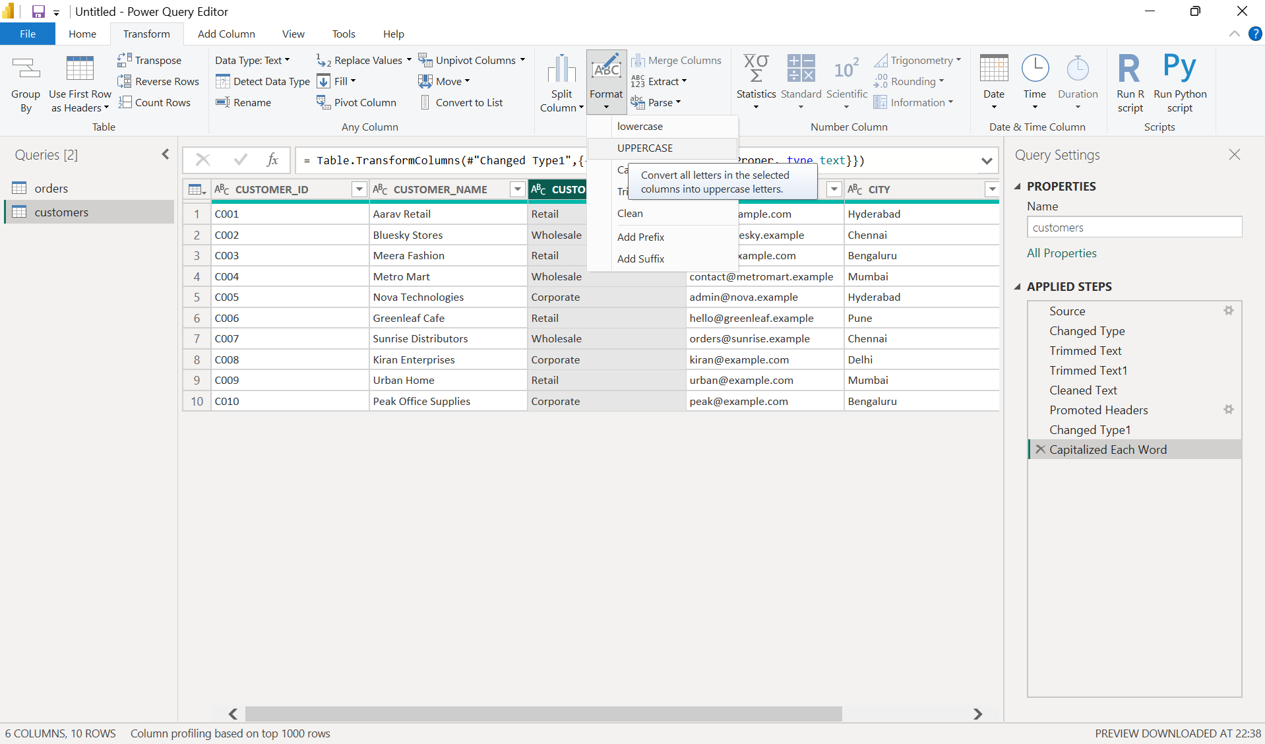

Handling Missing Values
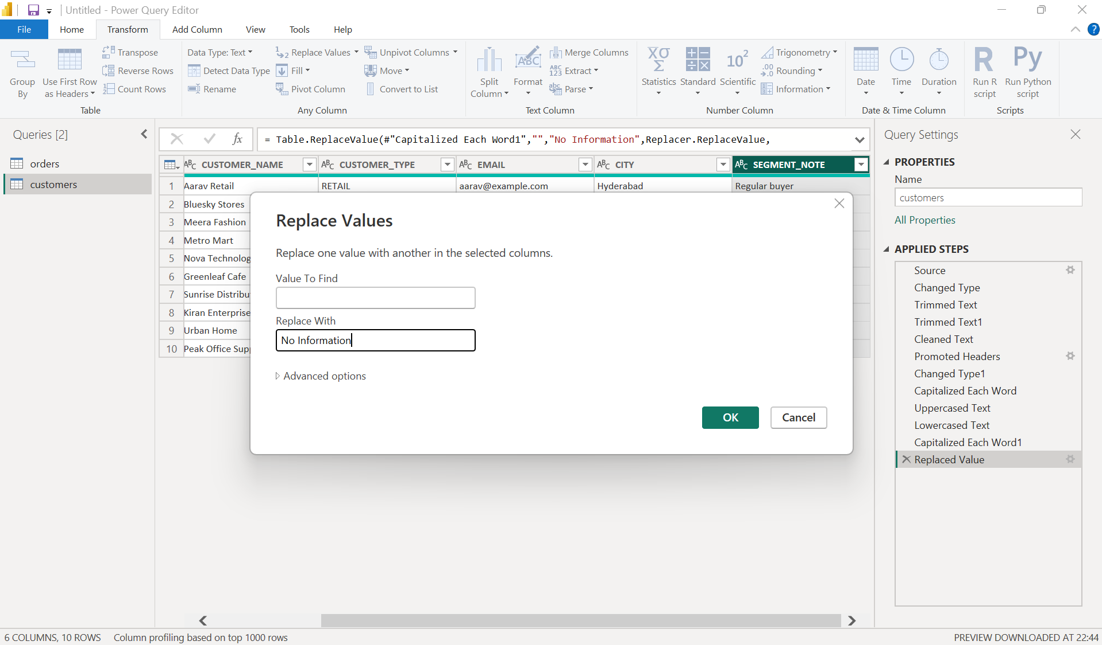
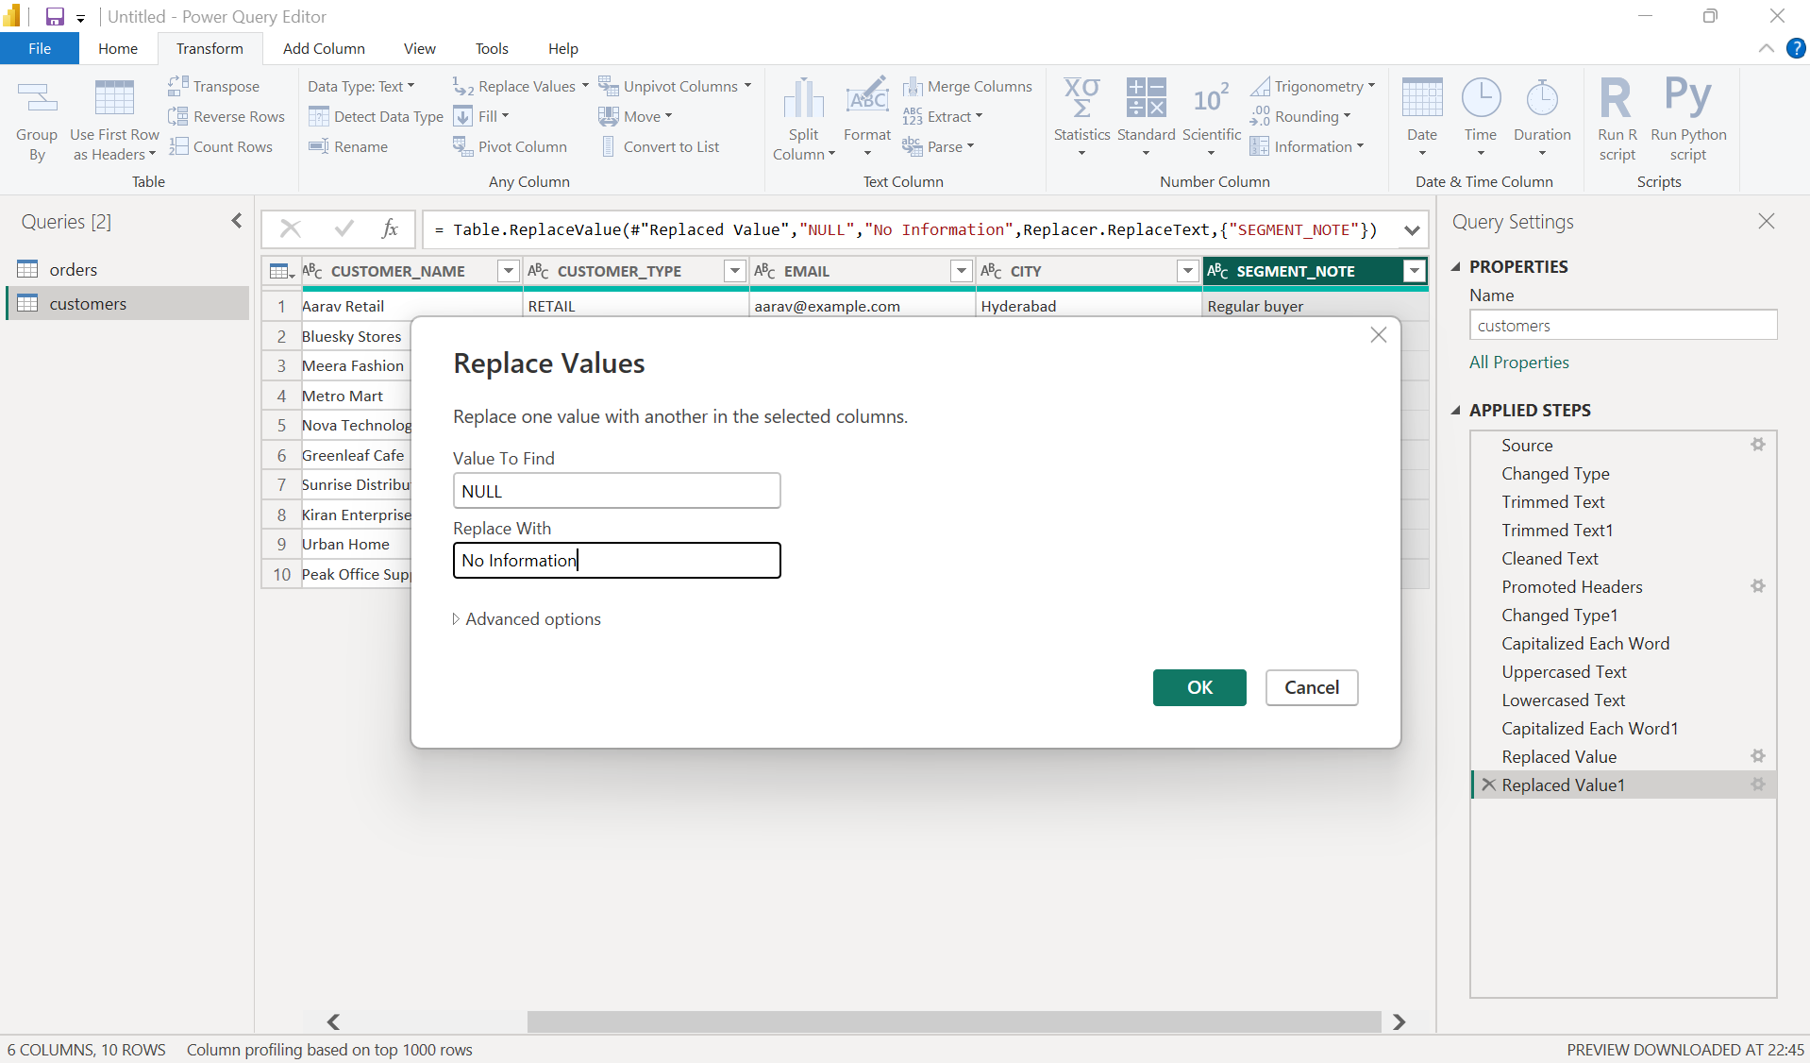

Removing Duplicate Records
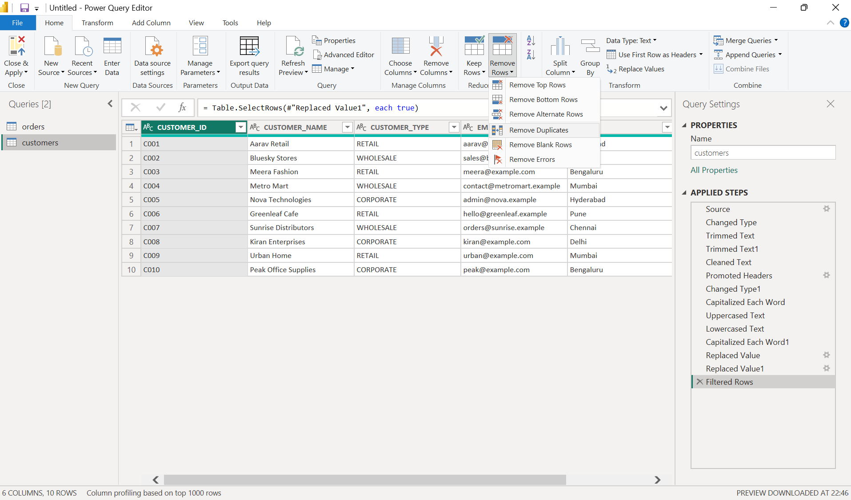

Changing Column Data Types
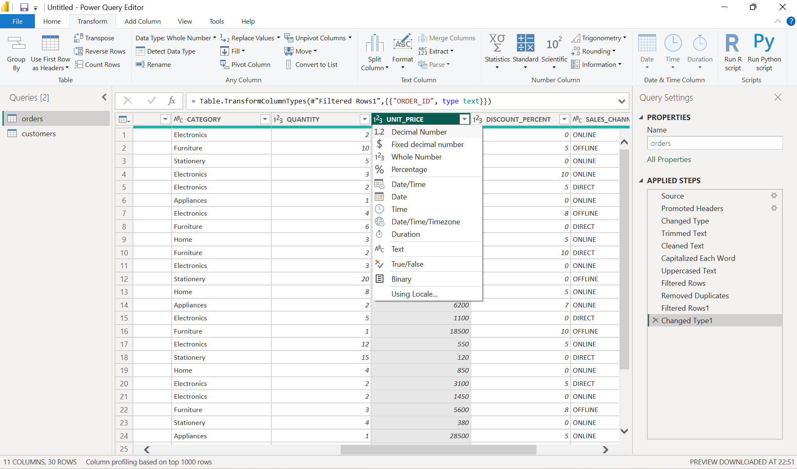

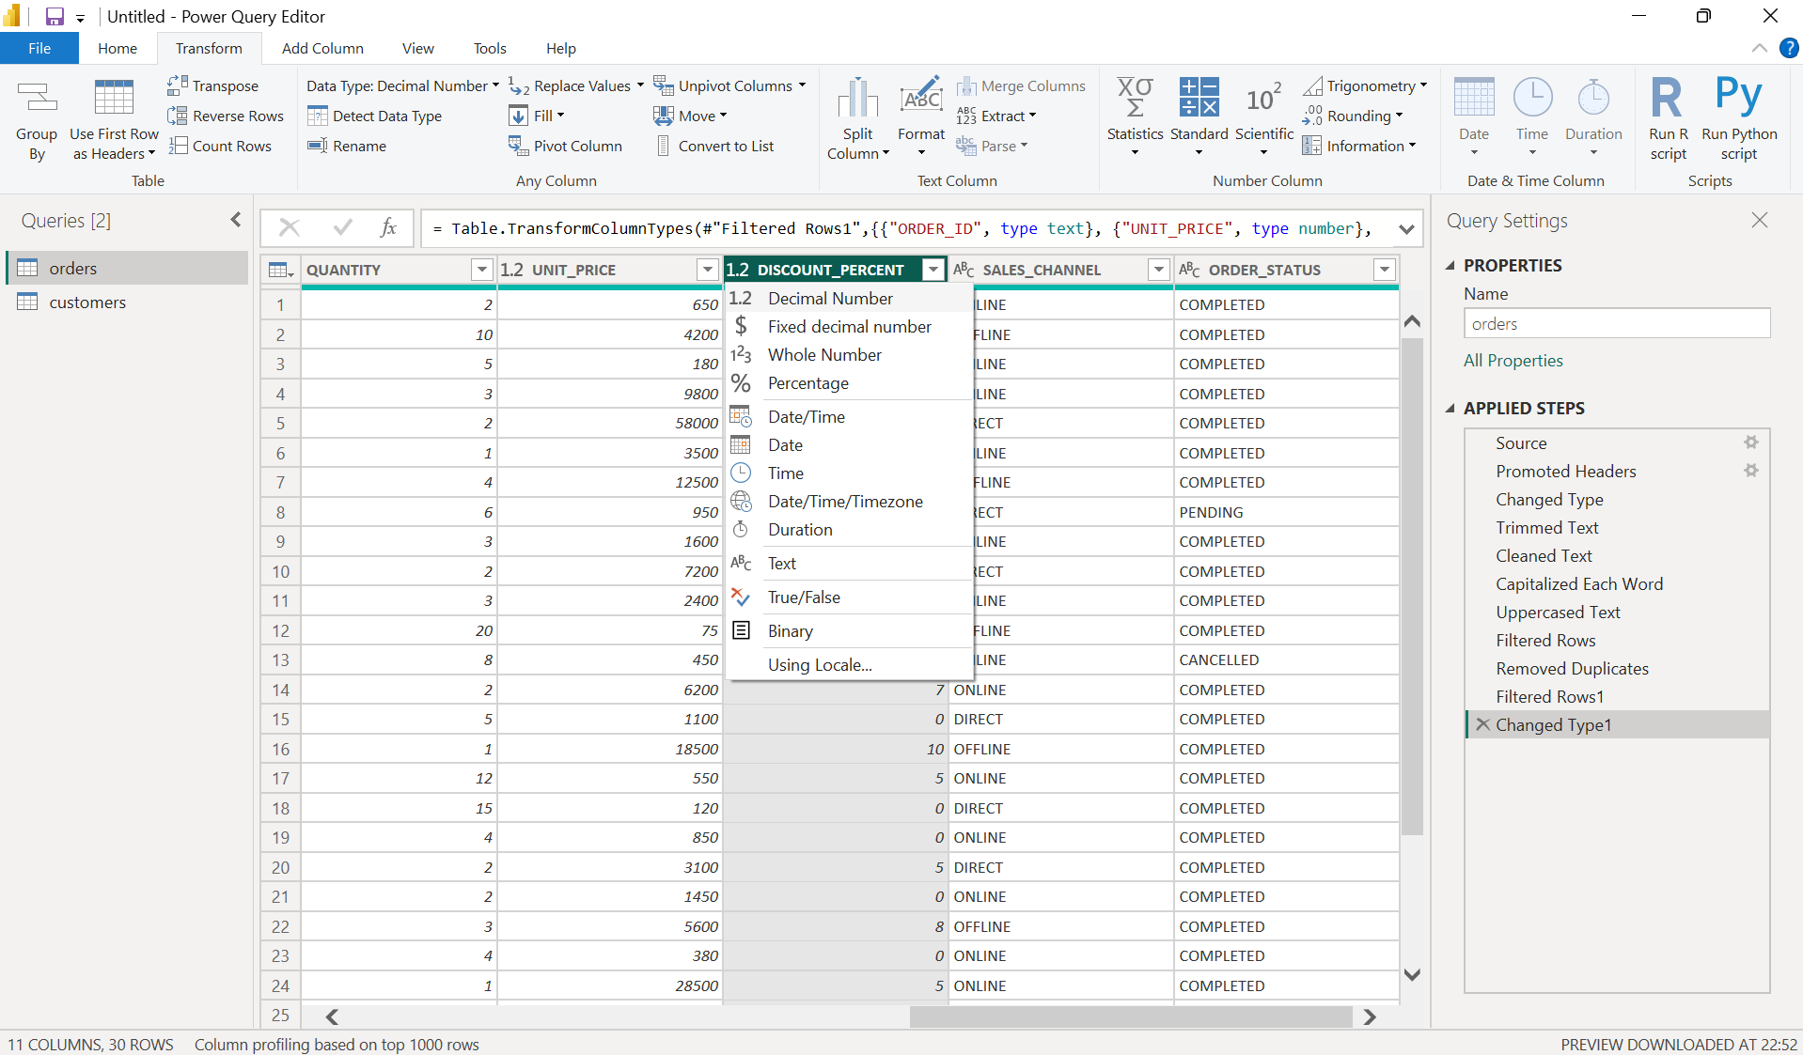

Creating the Revenue Column
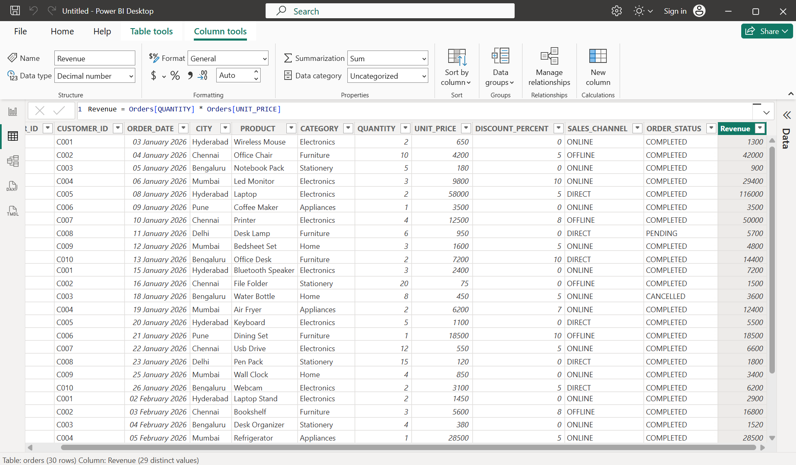

Creating the Discount Column
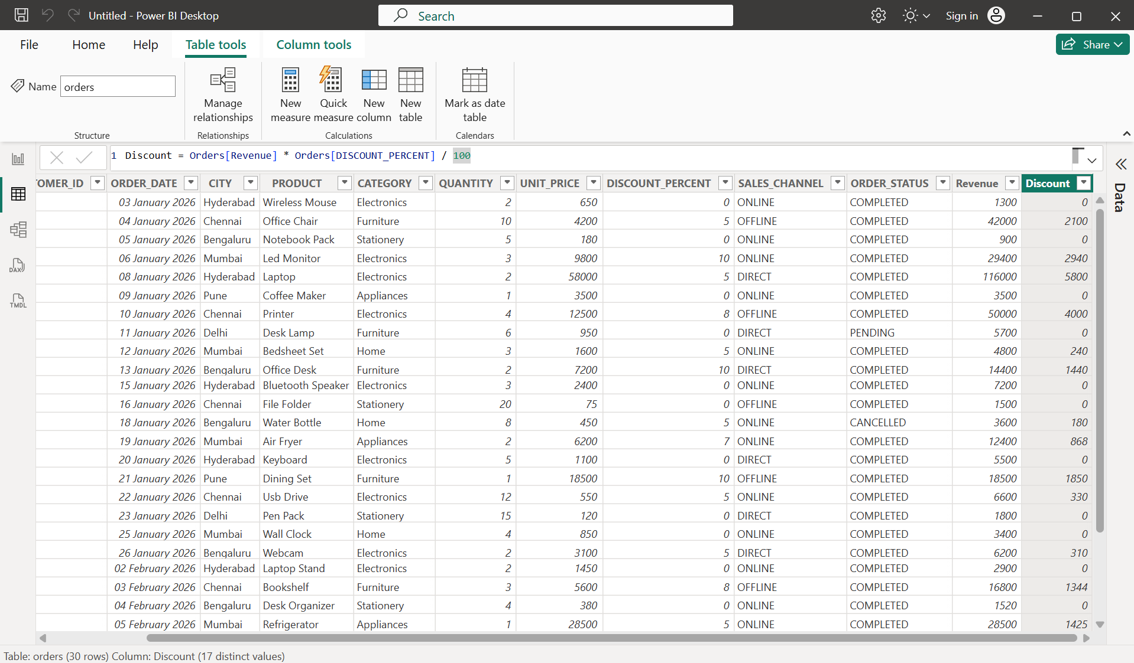

Creating the FinalAmount Column
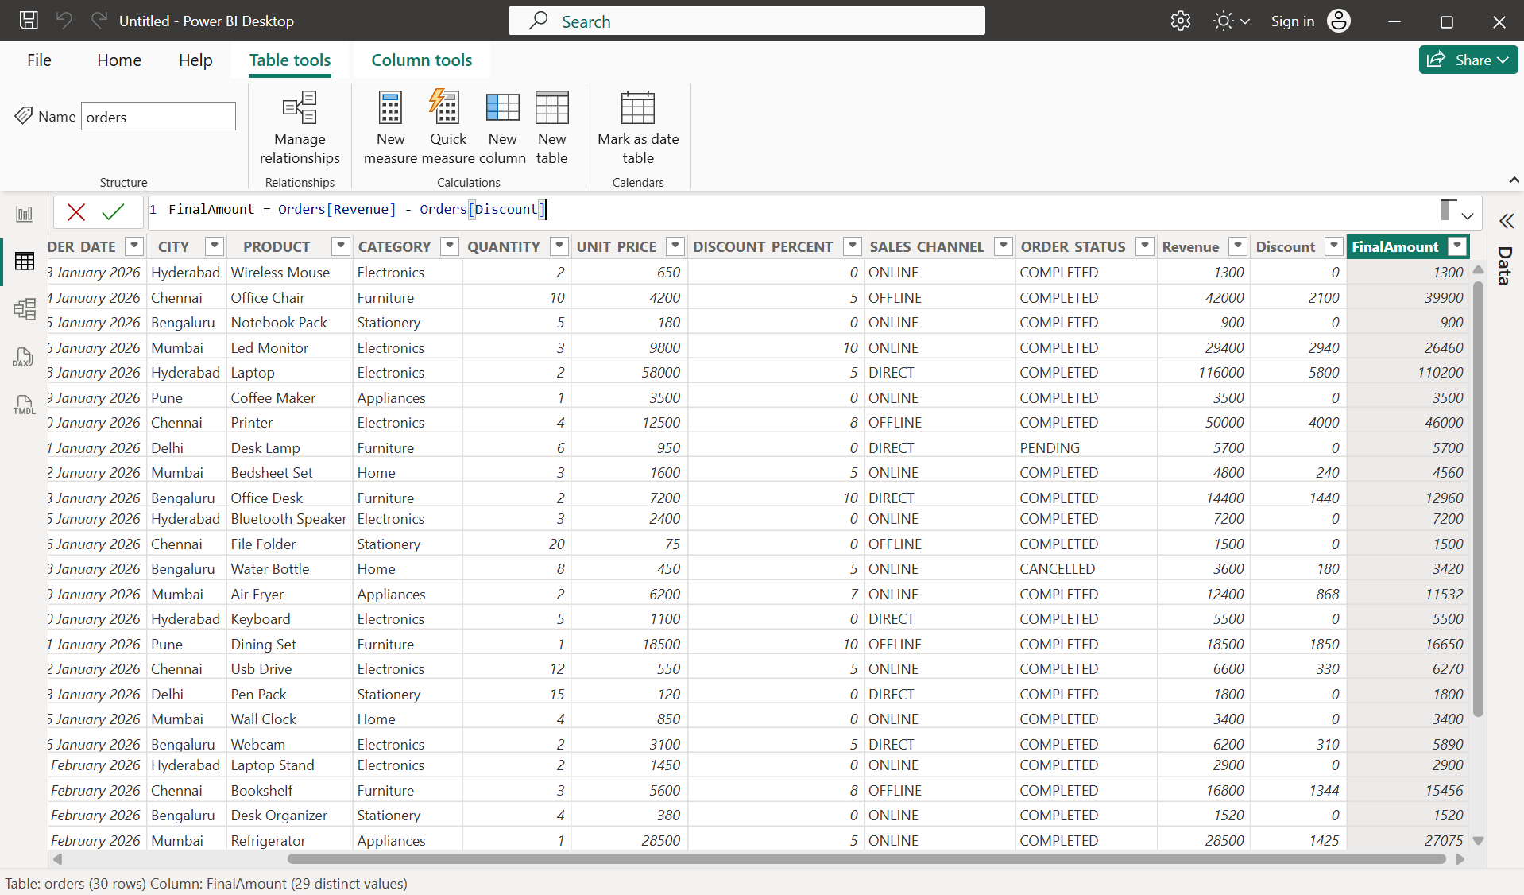

Creating the GST Column
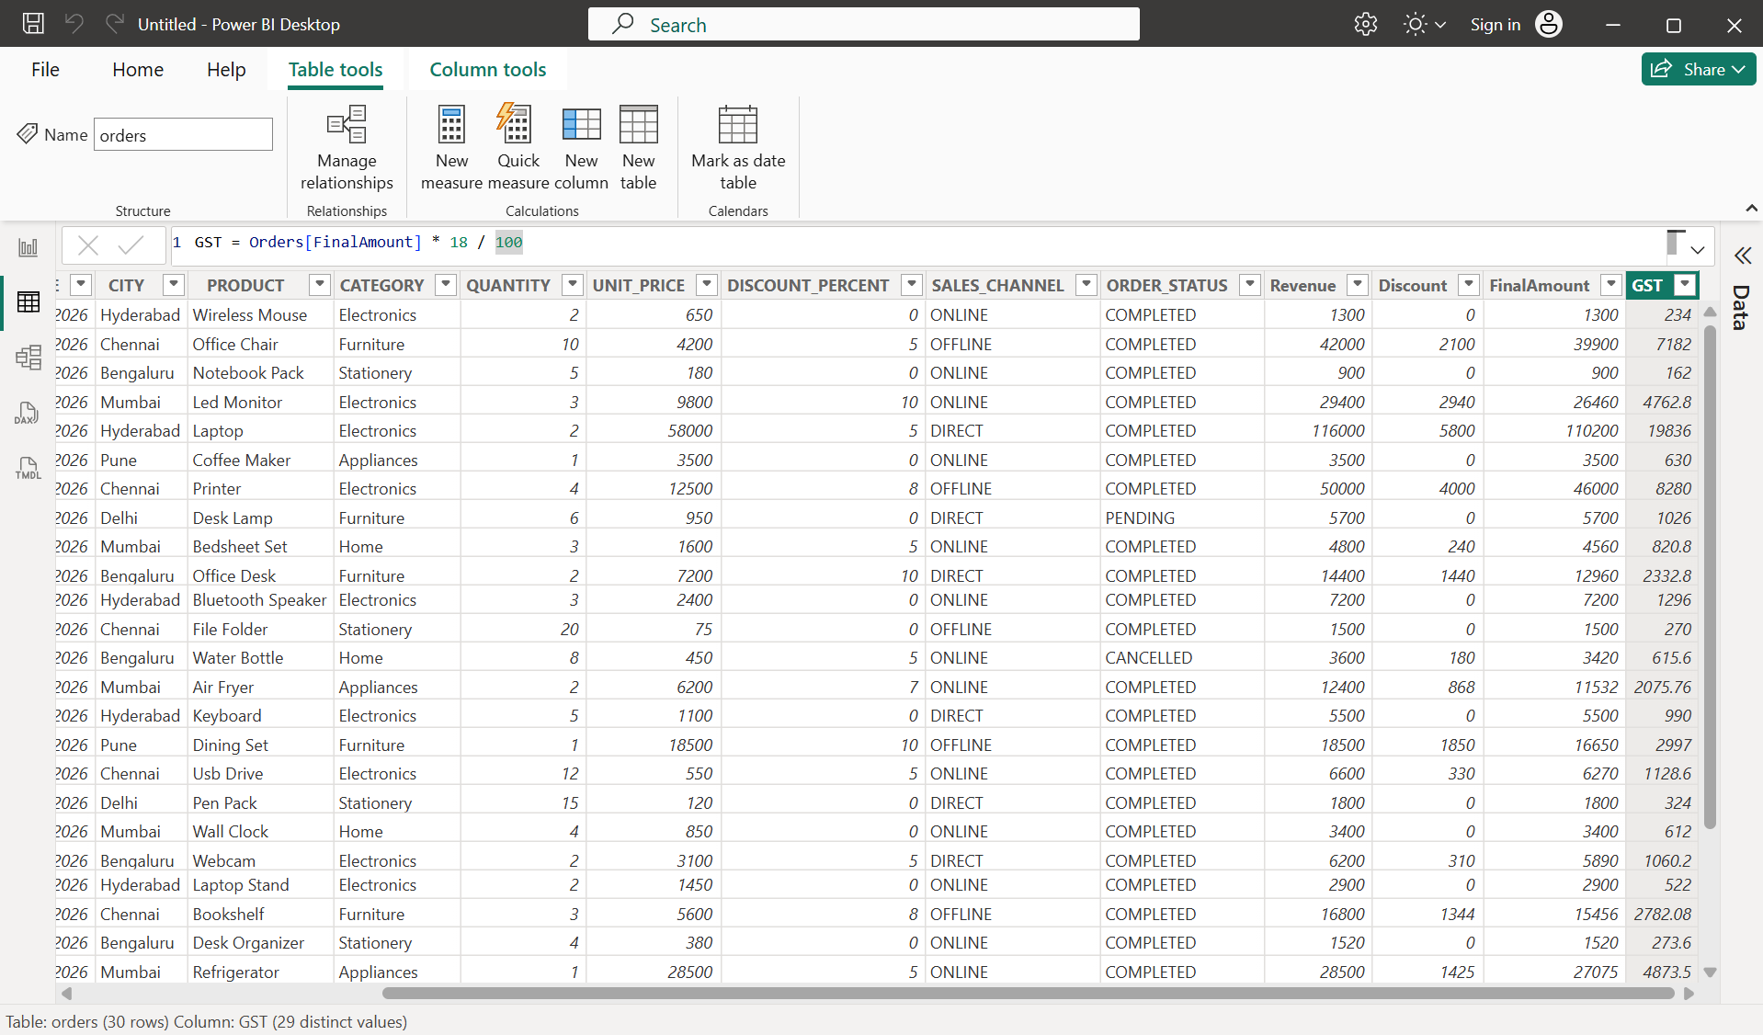

Creating the NetAmount Column
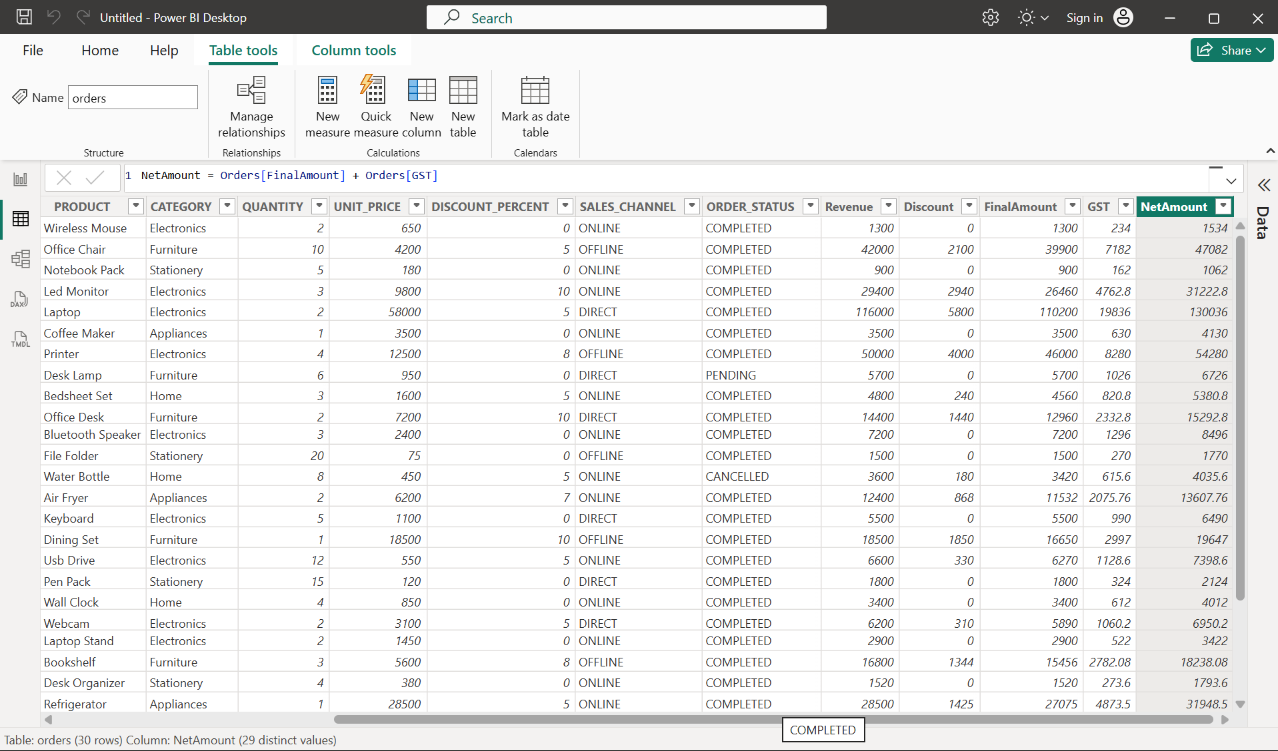

Creating the ProductType Column
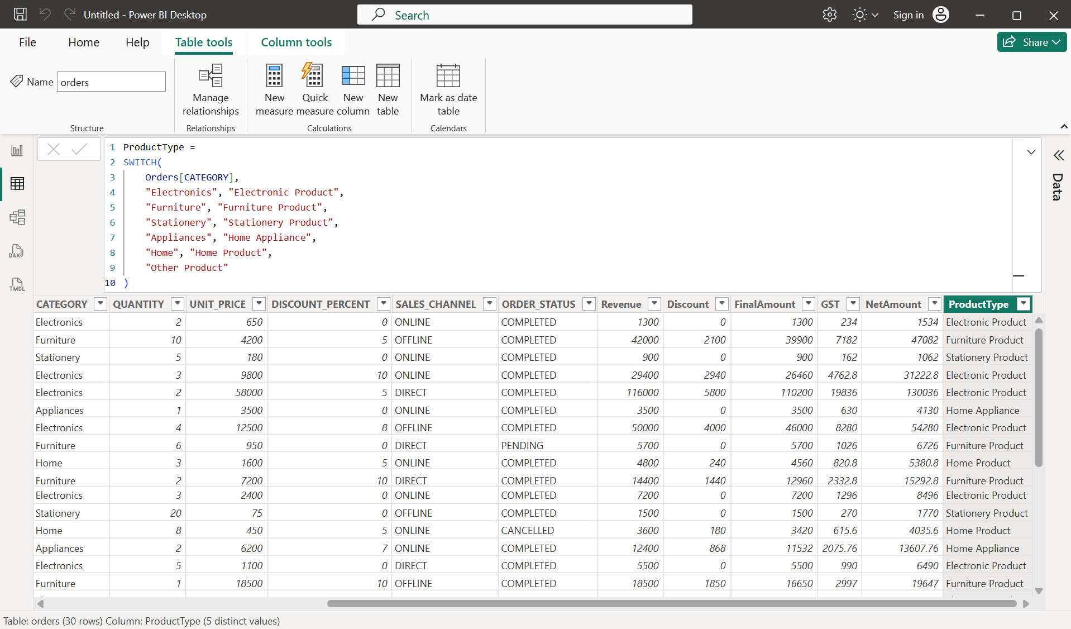

Creating the QuantityStatus Column
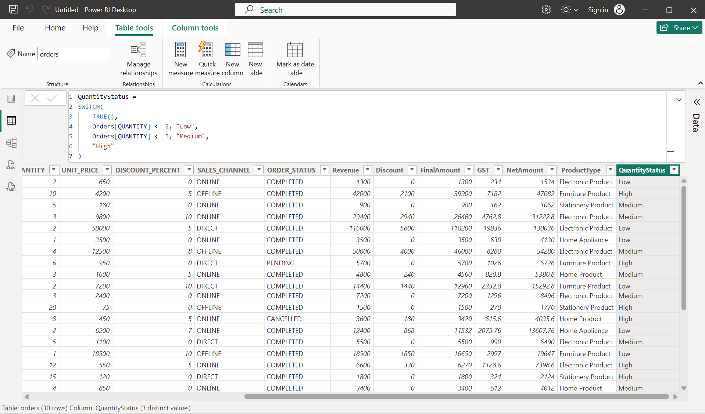

Creating the PriceCategory Column
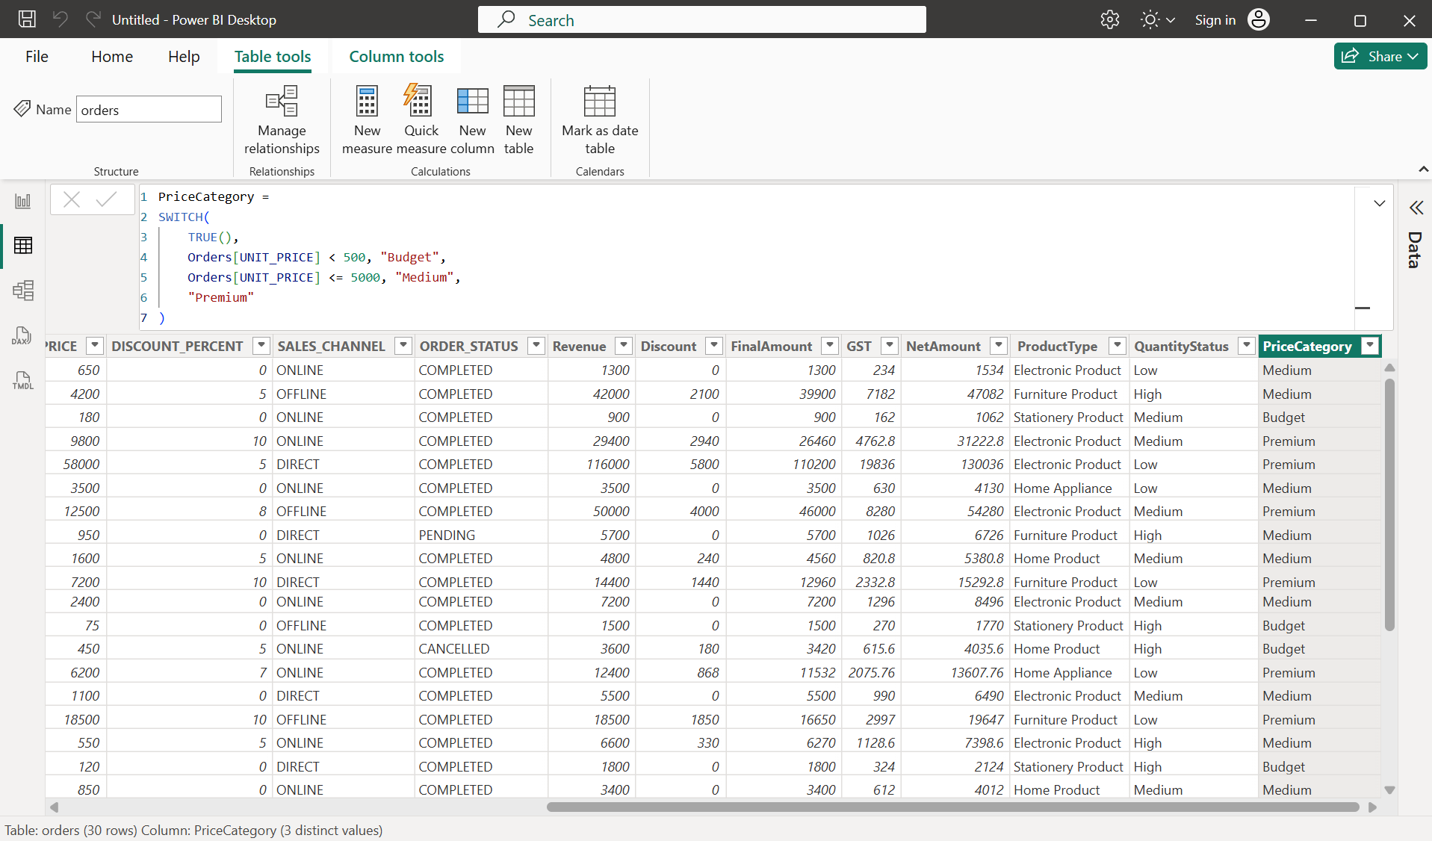

Creating the OrderMonth Column
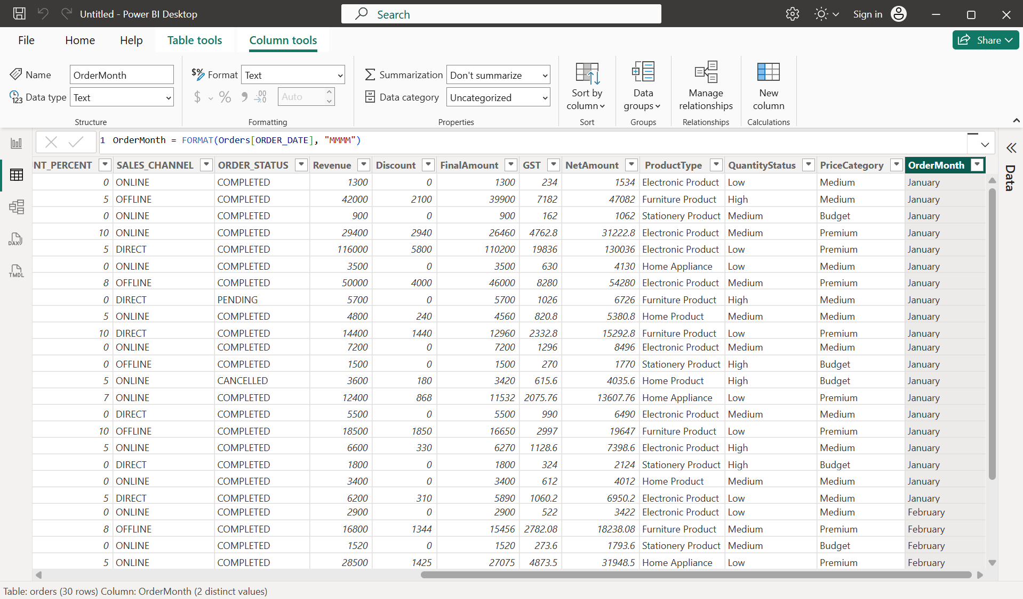

Creating the OrderYear Column
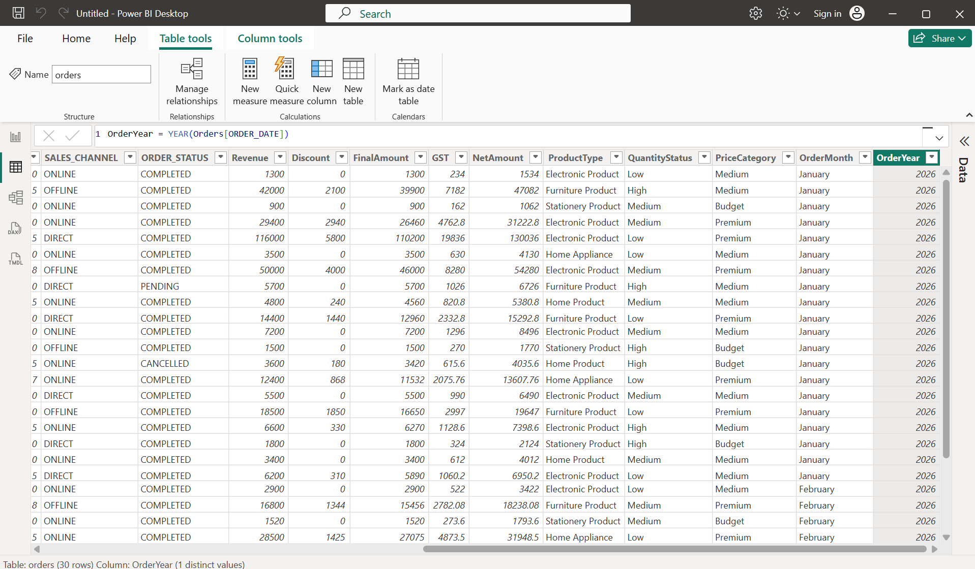

Creating the OrderDay Column
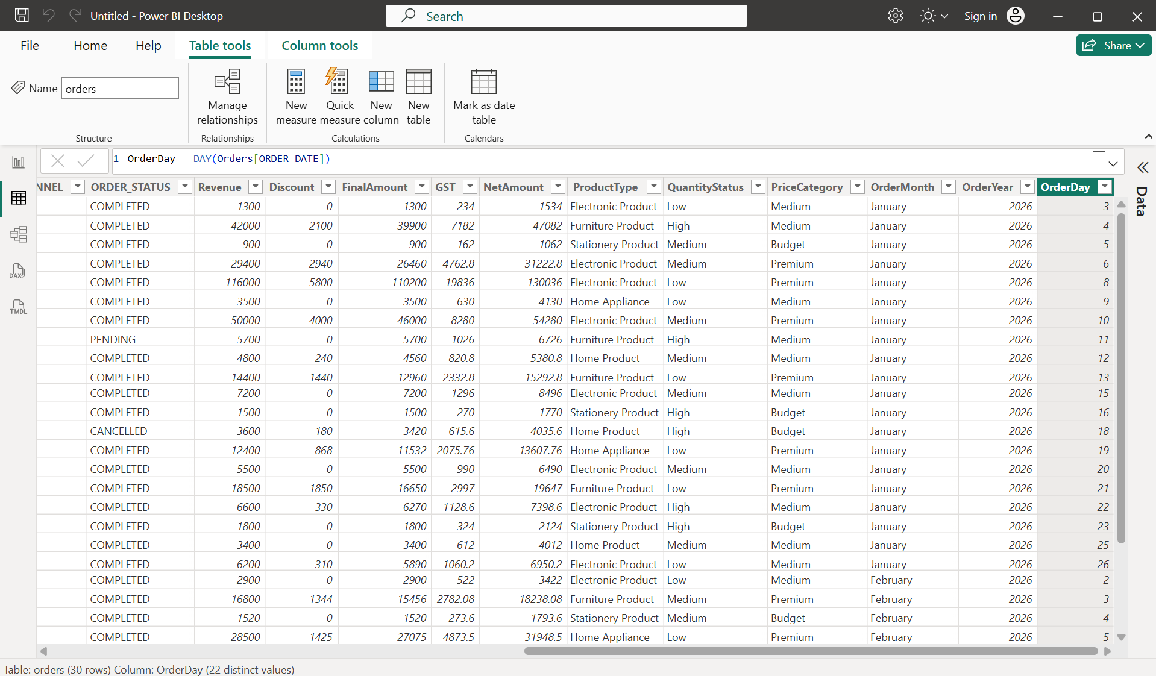

Creating Relationships Between the Two Tables
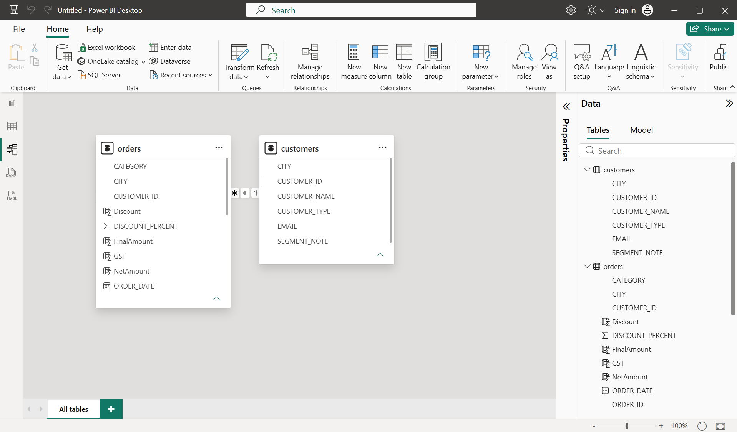

Verifying One-to-Many Relationships
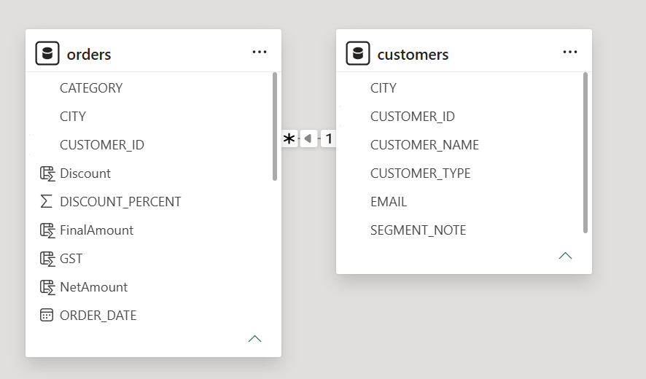

Creating measures for business analysis

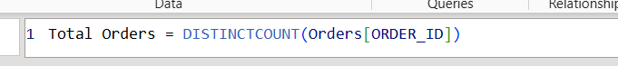

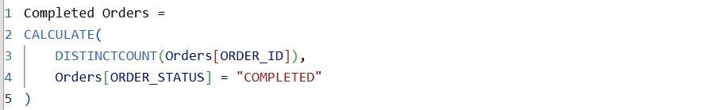

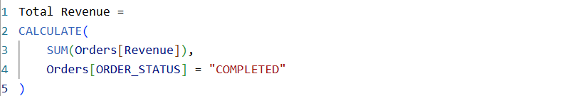

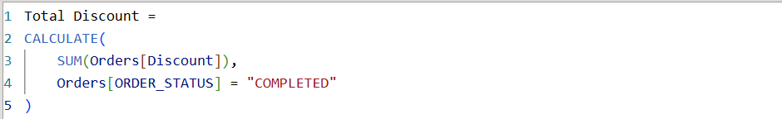

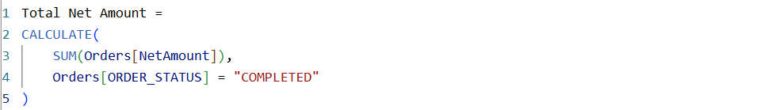

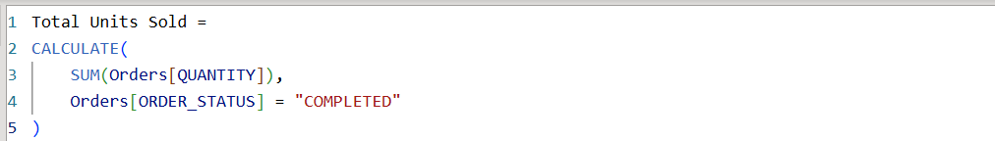
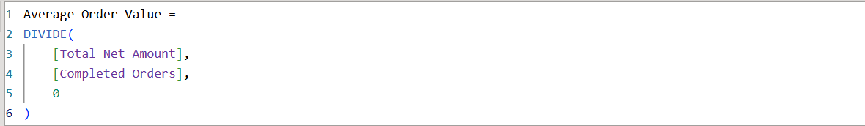

Creating Visualizations and Dashboard
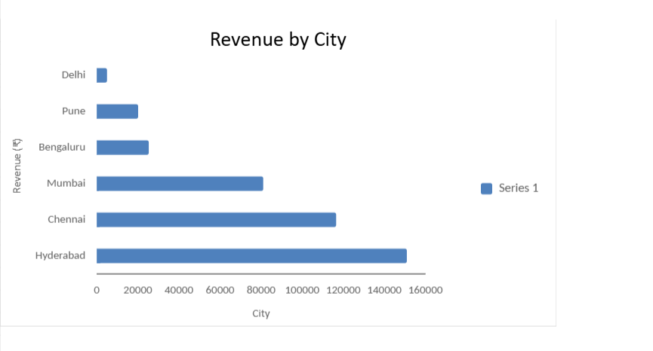
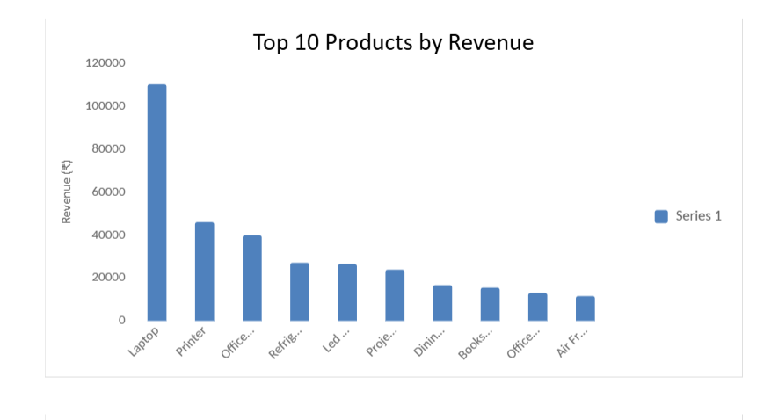

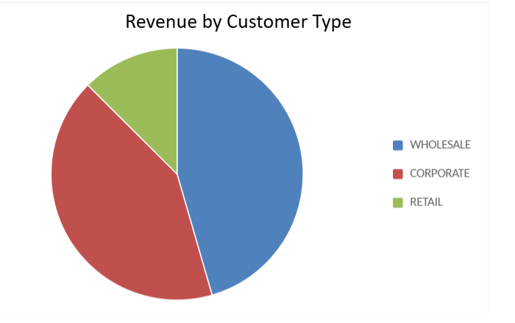

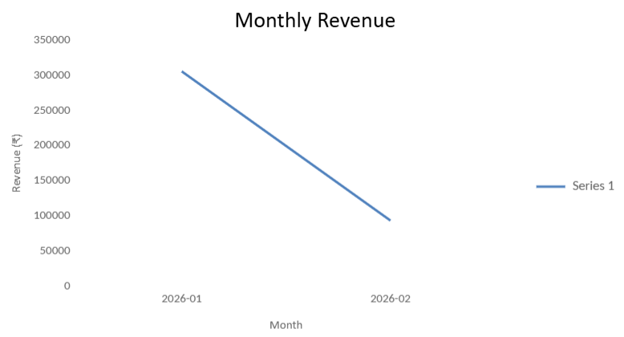

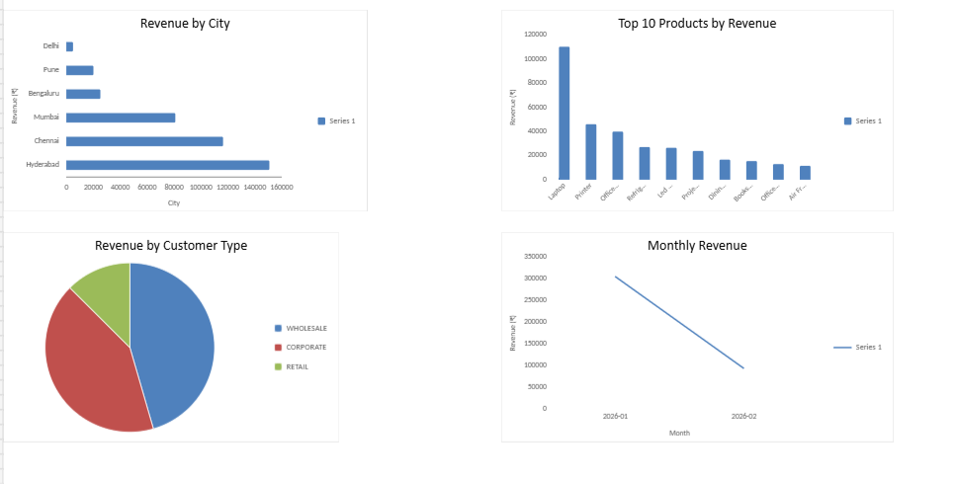

Final Report and Business Insights
- Successfully imported and analyzed 30 orders and 10 customer records using Power BI.
- Completed 27 orders, with 2 pending and 1 cancelled, generating ₹3,98,993 revenue after discounts.
- Hyderabad generated the highest city-wise revenue of ₹1,50,950.
- Laptops were the highest revenue-generating product, contributing ₹1,10,200.
- Wholesale customers contributed the highest revenue of ₹1,81,603.
- Created an interactive dashboard using KPI cards, charts and slicers to visualize sales performance, customer behavior and product trends.

